Topic of the Week Group-Dump

Hello All!
This is a compilation of past Topic of the Weeks. Please Use however it would benefit your Pub.

Here is how we tend to format.
- Create a checklist title of your idea.
- Bold and underline your title.
- Put 3 blue lines on both sides of your completed topic for easy readability. (Just copy and paste what’s already here.)

Ex:
- Body Image
- Music + Nostalgia
Topics of the Week

- Mobility + Roots X
- Childhood friendships
- Anniversaries
- Travel
- Retirement
- Killing
- Physically close v physically distant living arrangements
- How should people drive on the highway?
- The Role of Teaching
- Oaths
- Food Convenience
- Eugenics
- Memes in Society
- Sitting arrangements - chairs v on floors v on stools

Mobility + Roots
Society is very mobile, with people moving away to attend college or pursue jobs. Generational homesteads are a distant memory. What are the consequences, good and bad, of not being connected to your ancestral land? Do the benefits of easy movement outweigh the costs?
45
16 15 17

Childhood Friendships

What do our childhood friendships look like when we’ve reached adulthood? What are some things that happened that made some “live” while others “died?” What makes a childhood friendship different from an adult one?

Anniversaries

Our society only celebrates 2 public anniversaries: weddings + births. What makes these worthy of celebration? What other “things'' deserve a public anniversary? (Death? Divorce? Job?) Should some anniversaries stay private?

Travel

What is it about certain types of travel that fundamentally changes us? Why do some types of travel change us, but others don’t? How can we, at various levels of society, foster the “good” changes?

Retirement

What is the point of retirement? When one retires, what ought one do with that time? Do you still have responsibilities? To your family, community, or society? What are they? Who suffers if retirees have no responsibilities?

Killing

Who here has killed anything substantial? (Deer, dog, bunch of cats.) Does killing something change you, or provide a different perspective on life?

Physically close v Physically distant living arrangements

Underclassman college dorms v upperclassman college dorms. College v real world. Close communities v distant communities.

How should people drive on the highway?
What’s the point of the left hand lane? Congestion?

The Role of Decor in our Lives.
(No idea on a recommendation for stock photo)

How does our home decor (or room/dorm decor) reflect our personality and style? Why do we decorate? What are the consequences of having bad decorations, or neglecting home decor?

Cultural Appropriation with Globalization.
(A village on one side, the globe on another)

What is cultural appropriation and how does it differ from appreciation? How do we navigate the line between cultural exchange and appropriation? How can cultural diversity be preserved in an increasingly globalized world? What makes some cultures strong and survive and others weak and get appropriated or abandoned?

Body Image
(Image of the body + soul. Like one of those weird kabbalah designs.)

What is the relationship we have with our bodies? In what ways do changes in our bodies impact our interactions with the world around us? How do we cope with limitations of the body? Is this something that can be done alone?

Music + Nostalgia
(Image of person listening to music. Or someone listening to music very deep)

How does what happens at different periods of our lives affect what type of music we listen to? How does the music we listen to affect those time periods of our lives? What are some examples of certain songs that helped you through big moments, and WHY do songs help?

Topics of the Week
Topics are segmented by a triple blue line. The title is up top.
- Responsibility: Self and Society
- Philosophical Advancement
- Landlords
- Psychological Safety
- Fear and Death
- The Significance of Hairstyles and Haircuts
- The role of neighbors in our lives
- The Role of Decor in our Lives
- Cultural Appropriation with Globalization
- Body Image
- Music + Nostalgia

Responsibility: Self and Society
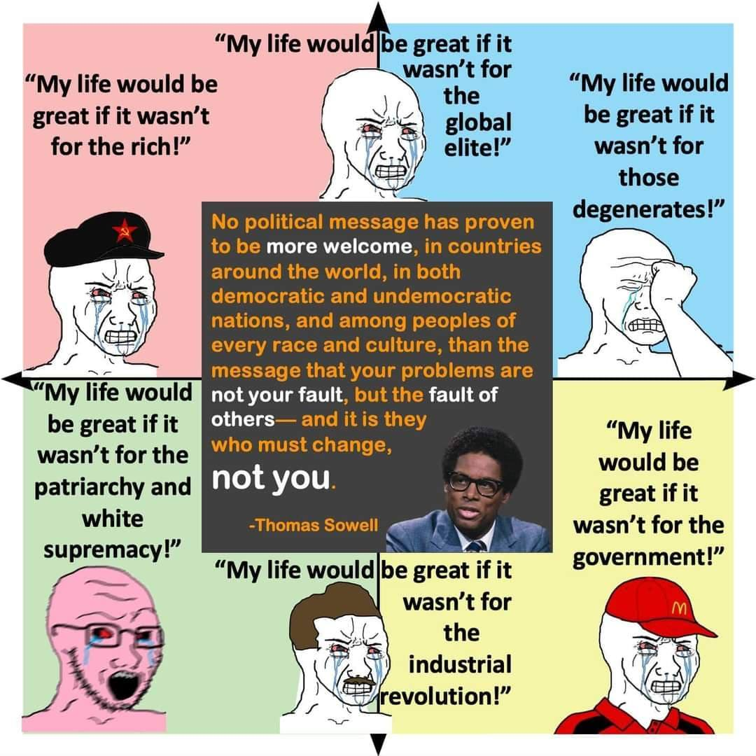

(Meme to provide context. Post it in the comments. Provide a stock photo for attention grabber)
To what extent are people responsible for their own actions? Where is the line between when something is society’s fault and what is your fault? To what extent do you not contribute to society and it’s problems?
“If I looked at my self - I would see I am the enemy
I am not honest nor kind nor caring nor sharing
Or any of the many thing that I pretend to be
I'm selfish and arrogant, and obedient
Follow truth only when it's convenient
Accept laws that I know that deceive me
So I can sleep in my bed easy
Don't blame governments, they are just us
If they are corrupt, then we are corrupt
Look back through history
What makes you think that we would act differently?
If we were in power, we would devour
Whoever the underclass were like cowards"
Akala - Welcome To Dystopia

Philosophical Advancement
- 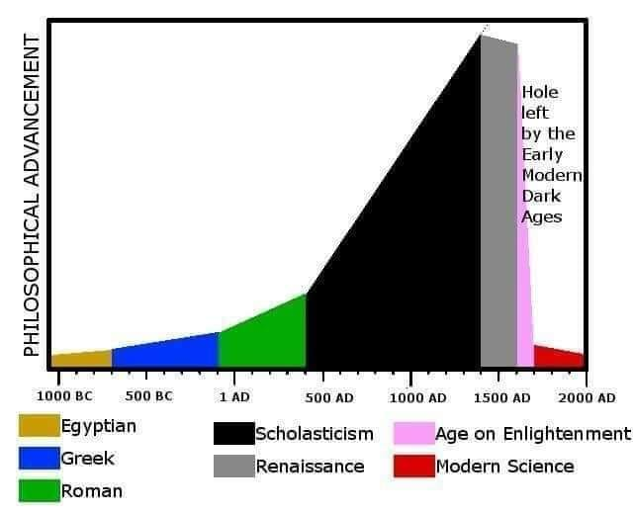
(Meme to provide context. Post in comments. Provide a stock photo for attention grabber) Is philosophical advancement a real thing? Do societies build off previous philosophies, like scientific advancements, or do they completely create their own philosophies generation to generation? Does each generation necessarily ask the same questions, and do different cultures ask the same questions? As some societies may regress scientifically, what causes societies to degrade “philosophically”?

NOT READY

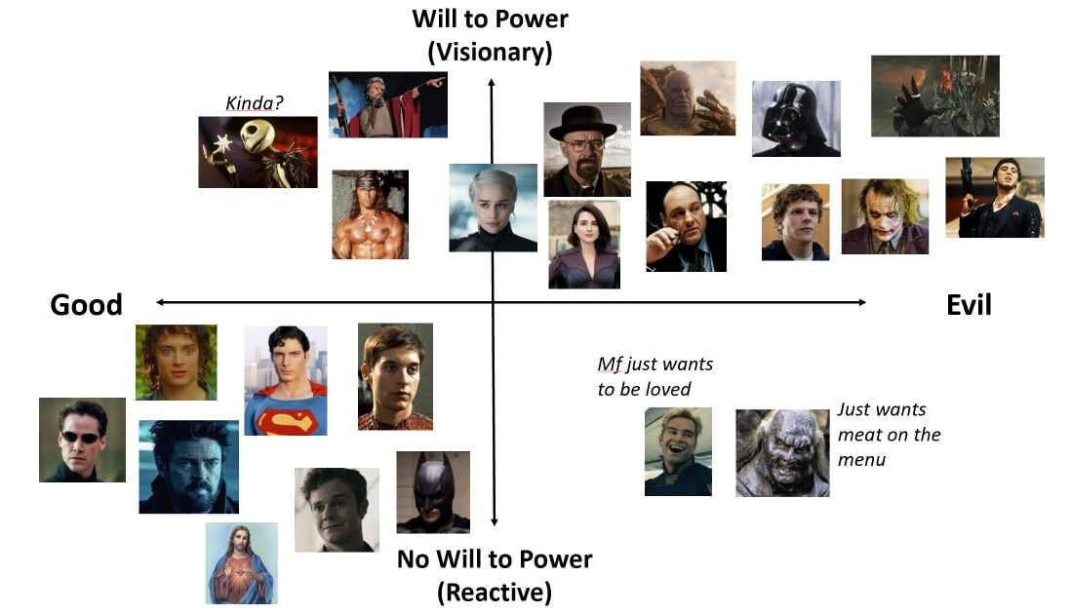
Just want to talk about this meme. It came with the caption: “Plans are bad. Status quo is good.” Formulate it as you’d like. This meme came with the caption: “Plans are bad. Status quo is good.” In modern american hero stories, the good guys are often reactive. The bad guys often want to change how things are, while the good guys don’t actively create, they just want to “stop the baddies.” This suggests that, with baddies removed, life is naturally good. Discuss.
Under what circumstances is it necessary for good guys to actively create?

Landlords

Landlords (picture of Landlord paint)
Should Landlording as a profession exist? It’s existed in various forms since ancient Babylon. In modern America, what is the role of renting, both for businesses and individuals? If the profession were to change, or have additional rules placed on them, what should they be?

For Daniel: 43% of Rural Pennyslvanians rent. For various reasons. They’re elderly and can’t maintain a house, they’re a single parent and don’t have the time, or they don’t want to. If we get rid of landlording, who will take care of their house?
Also, owning a home is hard and expensive. How many times have you reshingled your house? Do you know who is trustworthy and who’s not? The cost of a bad laborer is a lot more than a restaurant, but in both situations your only recourse is to not go back. A landlord will “try more resturants” than you in your lifetime, and will know which contractors are trustworthy and which ones aren’t.

Psychological Safety
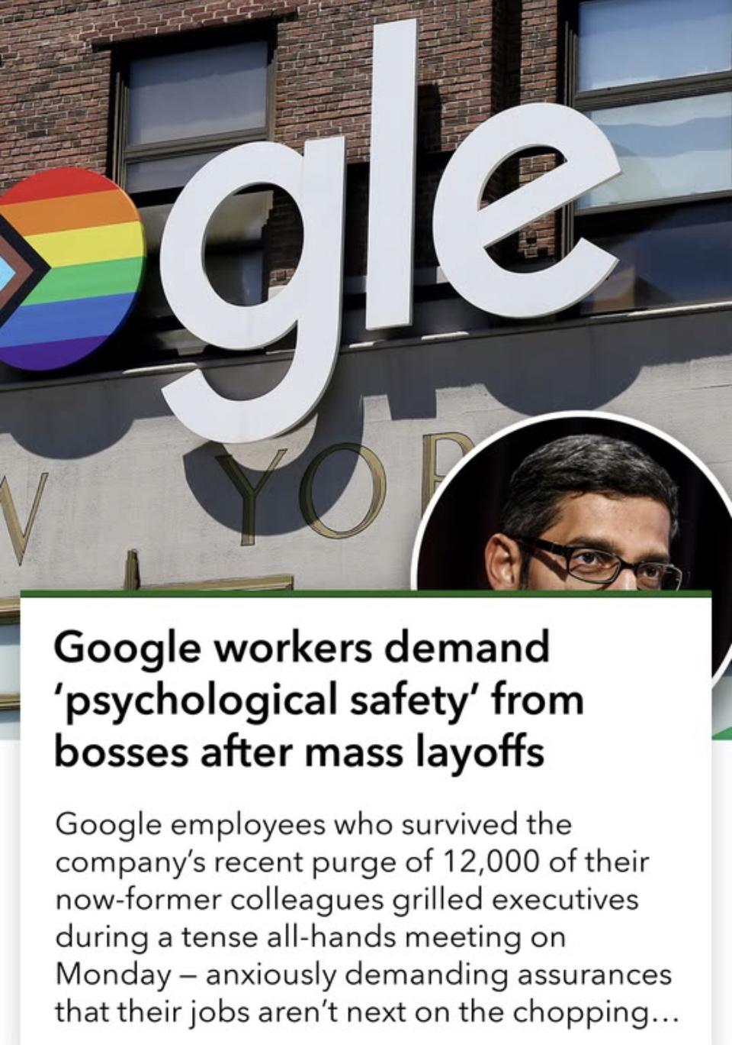

Need Stock Photo.

What constitutes psychological safety? What is a leader’s role in assisting psychological safety? (Be it parent, employer, society) Where does genuine psychological safety needs end and “toughen up” begin?

Fear and Death

Are you afraid of death? Why or why not? What are some fears not death related, and why do people have them? What is our culture’s relationship with death? What are some healthy aspects of it? What are some unhealthy aspects of it?

The Significance of Hairstyles and Haircuts.
(Stock photo of haircuts through the ages. If not, someone getting their haircut.)

How do our hairstyles and haircuts affect our identities and how we are perceived by others? What are some cultural and historical meanings behind certain hairstyles? In modern America, what is the role plays in society?

The Role of Neighbors in our Lives.
(stock photo of two houses side by side. Or peoples standing outside their homes, or talking over a fence.)

How much do neighbors affect our daily lives? What are the benefits and challenges of having relationships with our neighbors? What are the consequences of having good (or bad) neighbors? Is there a difference between having good neighbors and having a good neighborhood? How do different living styles (city, country, suburbs) affect relationships with neighbors?

The Role of Decor in our Lives.
(No idea on a recommendation for stock photo)

How does our home decor (or room/dorm decor) reflect our personality and style? Why do we decorate? What are the consequences of having bad decorations, or neglecting home decor?

Cultural Appropriation with Globalization.
(A village on one side, the globe on another)

What is cultural appropriation and how does it differ from appreciation? How do we navigate the line between cultural exchange and appropriation? How can cultural diversity be preserved in an increasingly globalized world? What makes some cultures strong and survive and others weak and get appropriated or abandoned?

Body Image
(Image of the body + soul. Like one of those weird kabbalah designs.)

What is the relationship we have with our bodies? In what ways do changes in our bodies impact our interactions with the world around us? How do we cope with limitations of the body? Is this something that can be done alone?

Music + Nostalgia
(Image of person listening to music. Or someone listening to music very deep)

How does what happens at different periods of our lives affect what type of music we listen to? How does the music we listen to affect those time periods of our lives? What are some examples of certain songs that helped you through big moments, and WHY do songs help?

Body Image
(Image of the body + soul. Like one of those weird kabbalah designs.)

What is the relationship we have with our bodies? In what ways do changes in our bodies impact our interactions with the world around us? How do we cope with limitations of the body? Is this something that can be done alone?

Music + Nostalgia
(Image of person listening to music. Or someone listening to music very deep)

How does what happens at different periods of our lives affect what type of music we listen to? How does the music we listen to affect those time periods of our lives? What are some examples of certain songs that helped you through big moments, and WHY do songs help?

